Germany Exchange: Pingry & Weidigschule Butzbach
June 13-29, 2015

Pingry Global Education and the government-sponsored German-American Partnership Program are sponsoring an educational exchange with Weidigschule Gymnasium, a university-prep high school in Butzbach, near Frankfurt, Germany. You will learn what it is like to be a student at Weidigschule, attending classes with your host and making presentations to classes about life in the United States. You will stay at the home of your host student for the entire visit. This program is focused on an educational exchange, with students spending the majority of their time at the host school. After school and on weekends, students will tour the famous Cologne Cathedral, see the Hessian parliament with an alumnus of Weidigschule, visit museums and see the financial district of Frankfurt.

The trip is open to all Pingry students currently in grades 8-11. German language skills are encouraged but not required, as some German host families have suitable English skills to accommodate non-German speakers. There will be an opportunity to host a German student in New Jersey for ~16 days in October of 2015.
The lead faculty member for this travel course is Mr. Karsten Niehues (kniehues@pingry.org)

This travel course runs from June 13-29, 2015. The course fee is estimated to be $2750. If the cost of this program presents a financial hardship for your family, please contact Dale Seabury at dseabury@pingry.org for financial aid information. This course fee includes transportation, lodging, food, and travel insurance in Germany – basically everything except souvenirs.

As part of the reciprocal educational exchange, Weidigschule students that hosted Pingry students will travel to New Jersey for ~16 days in the fall of 2015 (tentatively scheduled for mid-October). Weidigschule students will attend school and afterschool activities at Pingry, as well as join Pingry-organized outings to NYC, Philadelphia, and Washington D.C. Host families would ideally make our German guests a temporary part of their family. Hosts need to provide a separate bed (preferably a separate bedroom) for the German student, provide breakfast/dinner, and arrange for getting them to/from Pingry during the two school weeks they are here. There would be a few unscheduled weekend days where host families could share with their guest their favorite local places/activities.

You do not need to host a German student in order to participate in the travel program to Germany, but the program will not run if we do not have enough Pingry hosts, so we hope you will host if you are able.
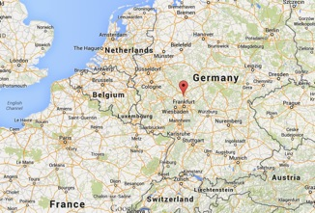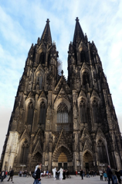
Germany Exchange Brief Itinerary – June 13-29, 2015
- Day 1: Travel to Germany
- Day 2: Orientation: welcome lunch, group bonding activities
  - Hosts all 10th graders, gender match, Pingry students usually get own bedroom
- Day 3 & 4: Weidigschule School visits – follow partner student around classes
  - Guided tour around school, Welcome reception at school, prepare for presenting to German classes.
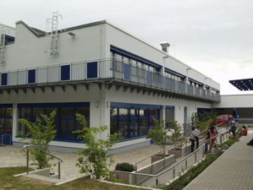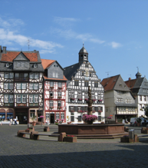
- Day 5: Weidigschule – Pingry students give presentations in German to classes at Weidigschule
- Day 6: Tour of Frankfurt – historic old city & Goethehaus
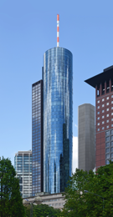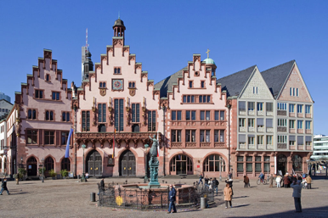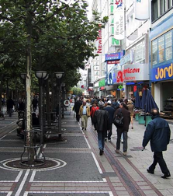
- Day 7: School - presentations to classes
- Day 8: tour of state capital and parliament with President of Parliament & Weidigschule alum; Sensory museum in a castle (Schloss Freudenberg)!
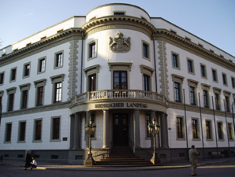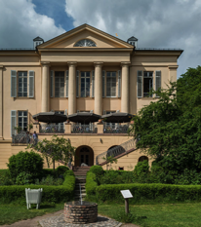
- Day 9: excursions with host families
- Day 10-14 School: attend classes, make presentations
- Day 15: Tour of Cologne and it’s world-famous cathedral
- World Heritage site, largest Gothic Cathedral in Northern Europe
- Day 16: Farewell party; time with host families
- Day 17 – return home to USA

Questions:
Jeff Jewett, Director of Global Programs, jjewett@pingry.org, 908-647-5555 x1346
Karsten Niehues, German Faculty, kniehues@pingry.org

